i-Finance UAT Results — Analytics Loader (App 208)
Automated UAT run · Round 1 · 18-Jun-2026 · Environment: http://localhost:8091 (dev-proxy -> ADB PROD)
Executed by Claude (Playwright + ORDS). Scope: the OTBI->ATD control plane — dashboard, jobs CRUD + enqueue/reset, queue ops, run logs + CSV export, environments + targets CRUD, and UI-managed Runner Settings. Personas: SYS_ADMIN (ADMIN) and a non-admin (NASER.ALKHAJA). Test data created during the run is prefixed "UAT".

Summary
26 cases — PASS: 26
Area | Cases | Pass | Fail/Other | Pass %
Access & Session | 3 | 3 | 0 | 100%
Dashboard | 2 | 2 | 0 | 100%
Jobs | 6 | 6 | 0 | 100%
Job Detail | 1 | 1 | 0 | 100%
Queue & Ops | 2 | 2 | 0 | 100%
Run Logs | 4 | 4 | 0 | 100%
Environments | 3 | 3 | 0 | 100%
Targets | 1 | 1 | 0 | 100%
Runner Settings | 3 | 3 | 0 | 100%
Cross-cutting | 1 | 1 | 0 | 100%

Access & Session

ATD-ACC-01 — Entry from Admin via switcher
PASS · Shared session · 11s
Expected: ATD (App 208) opens logged-in with no second login; AT brand cube; admin nav
Result: Entered ATD via the Admin switcher (shared session, AT brand, APP 208)
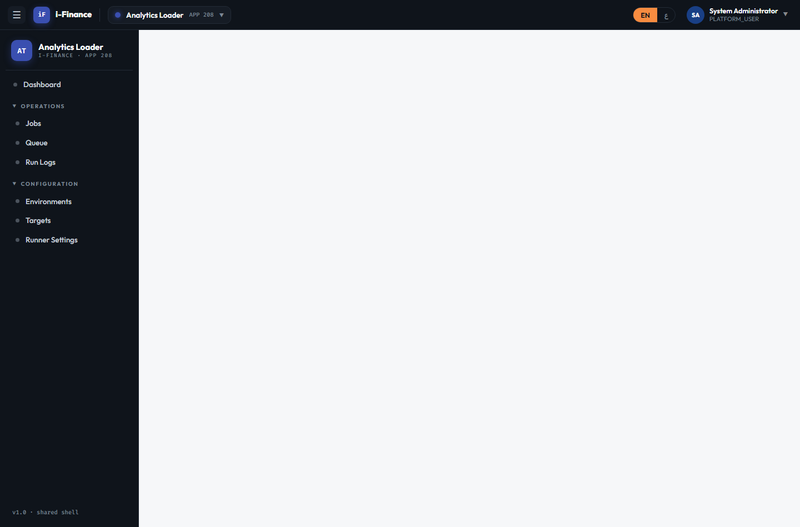
Evidence: ATD-ACC-01.png

ATD-ACC-02 — Direct open without login
PASS · No session · 5s
Expected: Redirected to the Admin portal login; no ATD content before login
Result: Direct open with no session redirects to the Admin portal
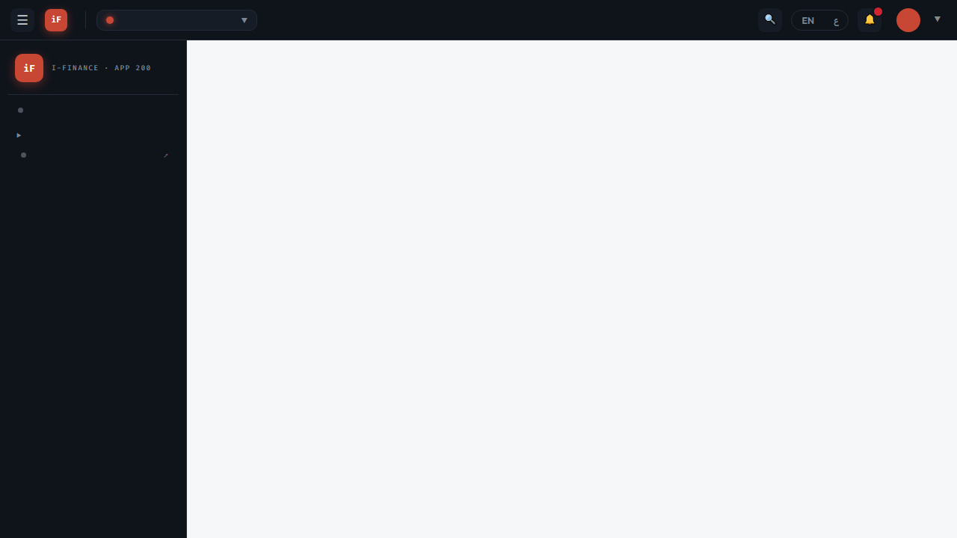
Evidence: ATD-ACC-02.png

ATD-ACC-03 — Non-admin blocked from the API
PASS · Admin gating · 2s
Expected: Denied with HTTP 403 (SYS_ADMIN required)
Result: Non-admin (CC_ADMIN) blocked from /atd/jobs with HTTP 403
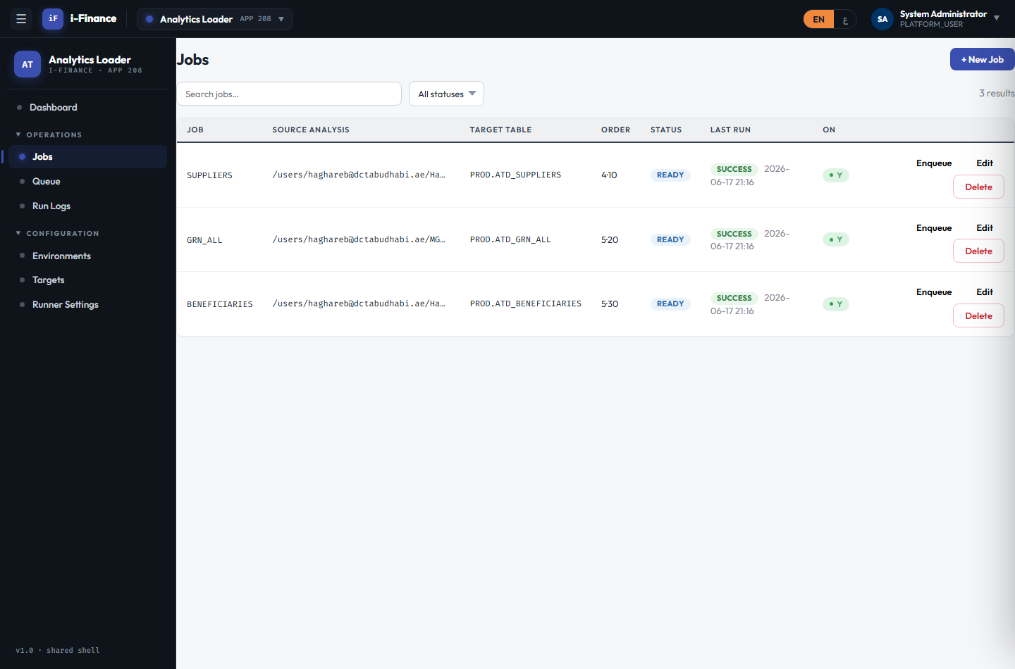
Evidence: ATD-ACC-03.png

Dashboard

ATD-DSH-01 — Five live KPI tiles
PASS · KPI tiles · 2s
Expected: Jobs / Enabled / Success Rate / Runs(24h) / Last Finished tiles show live numbers
Result: 5 KPI tiles; API jobs=3 enabled=3 successRate=100
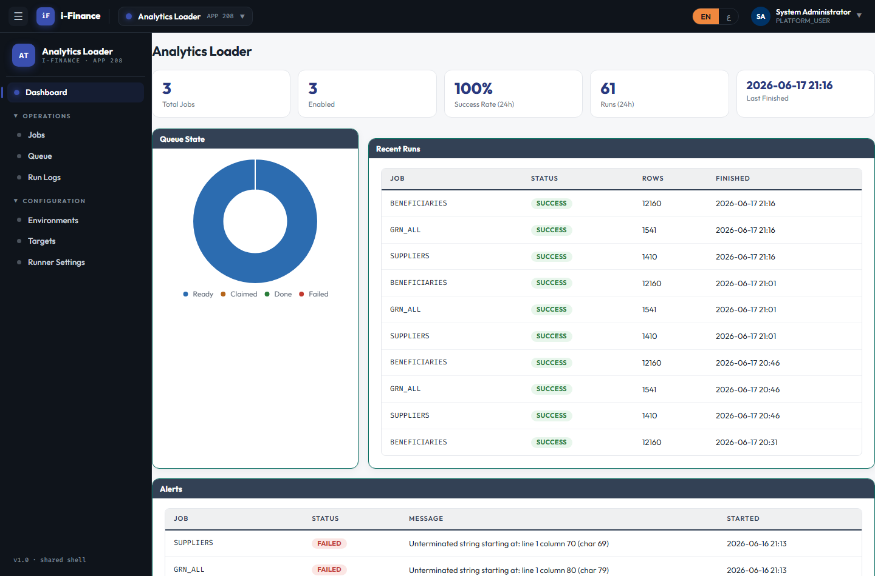
Evidence: ATD-DSH-01.png

ATD-DSH-02 — Queue donut + recent/alerts
PASS · Charts · 2s
Expected: Queue-state donut renders; recent-runs and alerts tables populate
Result: Queue-state donut renders; recent/alerts tables show 13 rows

Evidence: ATD-DSH-02.png

Jobs

ATD-JOB-01 — Job grid loads
PASS · List · 2s
Expected: Grid shows job, source, target, order, status, last run
Result: Jobs grid shows 3 rows; API total=3

Evidence: ATD-JOB-01.png

ATD-JOB-02 — New job via drawer/ORDS
PASS · Create · 2s
Expected: Job created and retrievable; appears in the grid
Result: Job UAT_TESTJOB created via ORDS and retrievable; grid refreshed
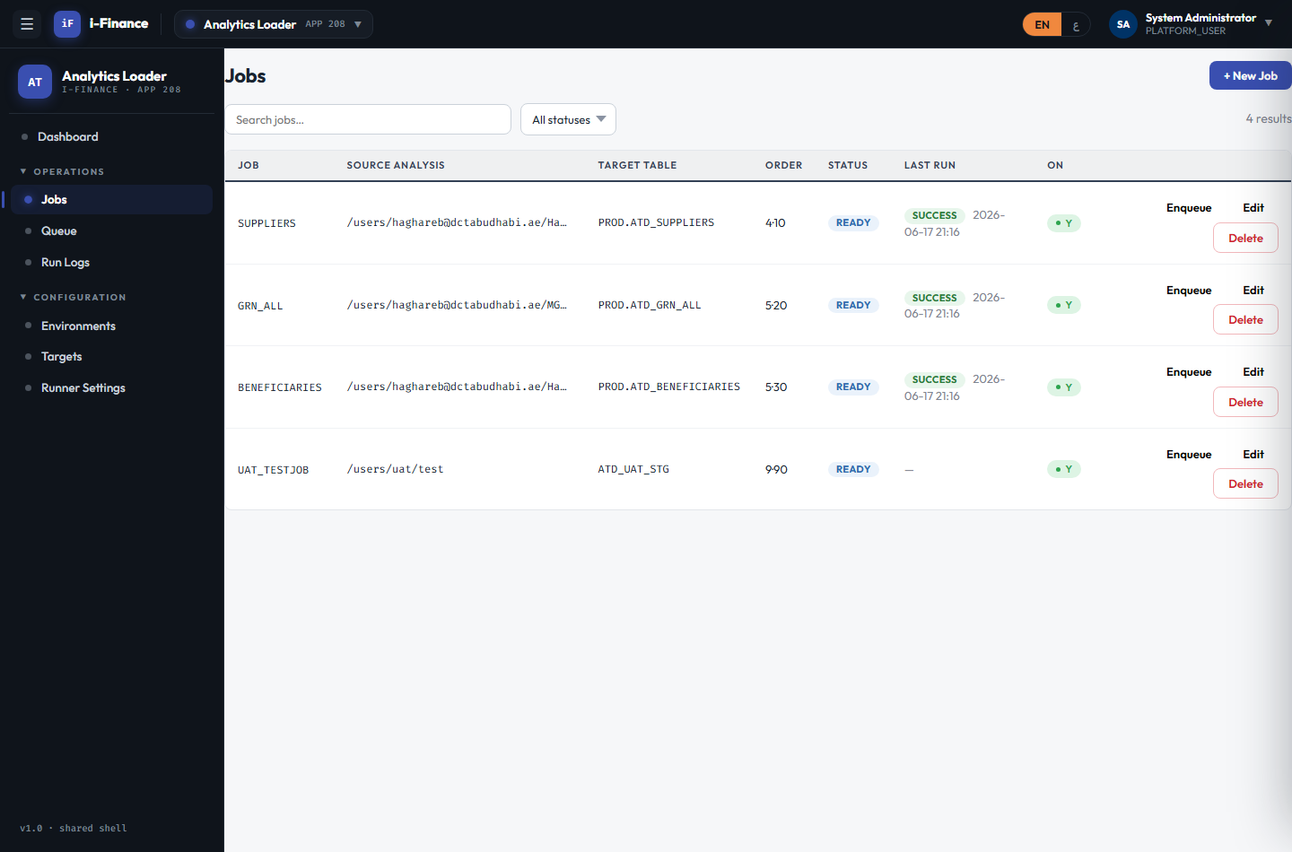
Evidence: ATD-JOB-02.png

ATD-JOB-03 — Edit persists
PASS · Edit · 2s
Expected: Change persists on reload (PUT)
Result: Edited priority -> 3, persisted on reload
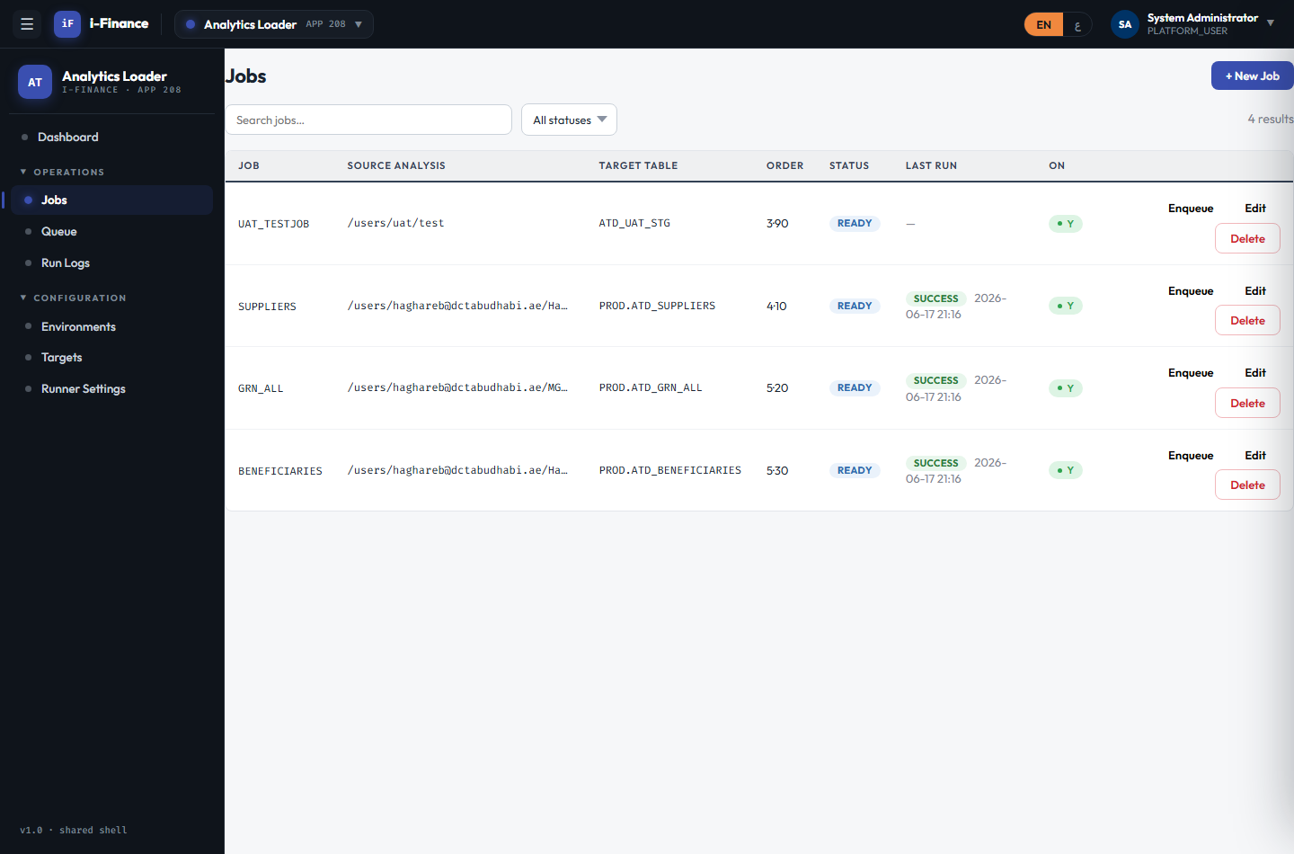
Evidence: ATD-JOB-03.png

ATD-JOB-04 — Duplicate name rejected
PASS · Duplicate · 2s
Expected: Rejected with HTTP 400 (boundary)
Result: Duplicate job name rejected with HTTP 400 (boundary)

Evidence: ATD-JOB-04.png

ATD-JOB-05 — Mark READY
PASS · Enqueue · 2s
Expected: run_status becomes READY (a worker would pick it up)
Result: Enqueue set run_status=READY (worker would pick it up)
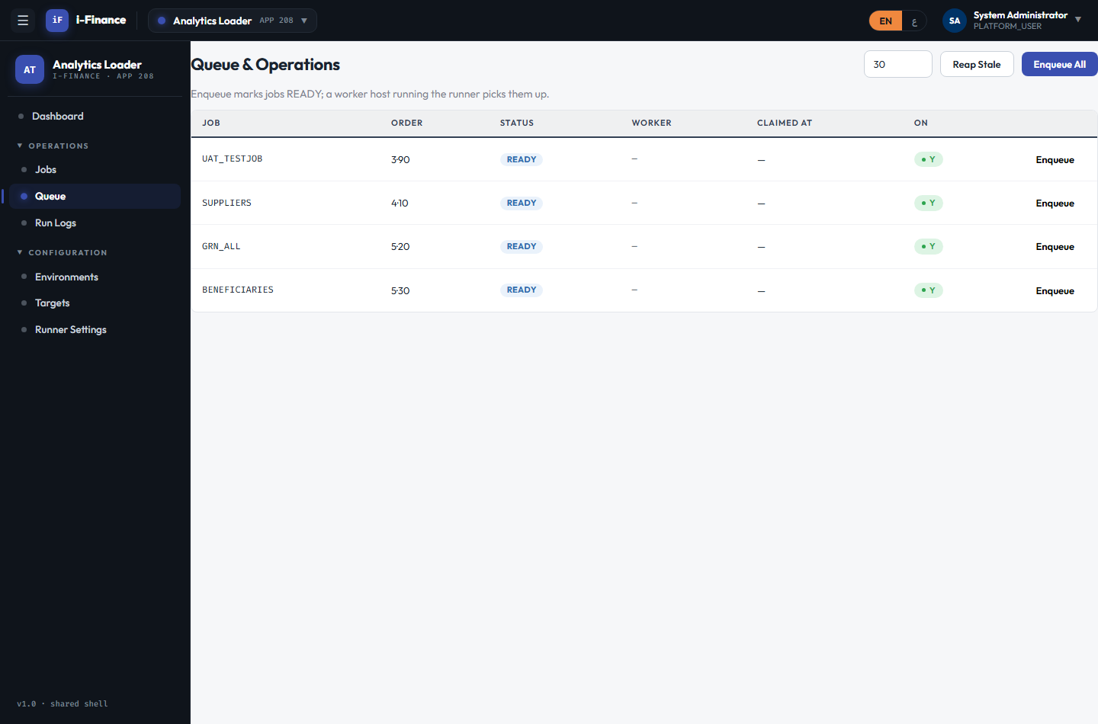
Evidence: ATD-JOB-05.png

ATD-JOB-06 — Remove a job
PASS · Delete · 2s
Expected: Job removed; GET returns 404 (history kept)
Result: Job deleted; GET now 404

Evidence: ATD-JOB-06.png

Job Detail

ATD-DTL-01 — Config + run history
PASS · Detail · 2s
Expected: Detail shows all config fields + run-history table
Result: Job detail shows config + 20 run-history rows
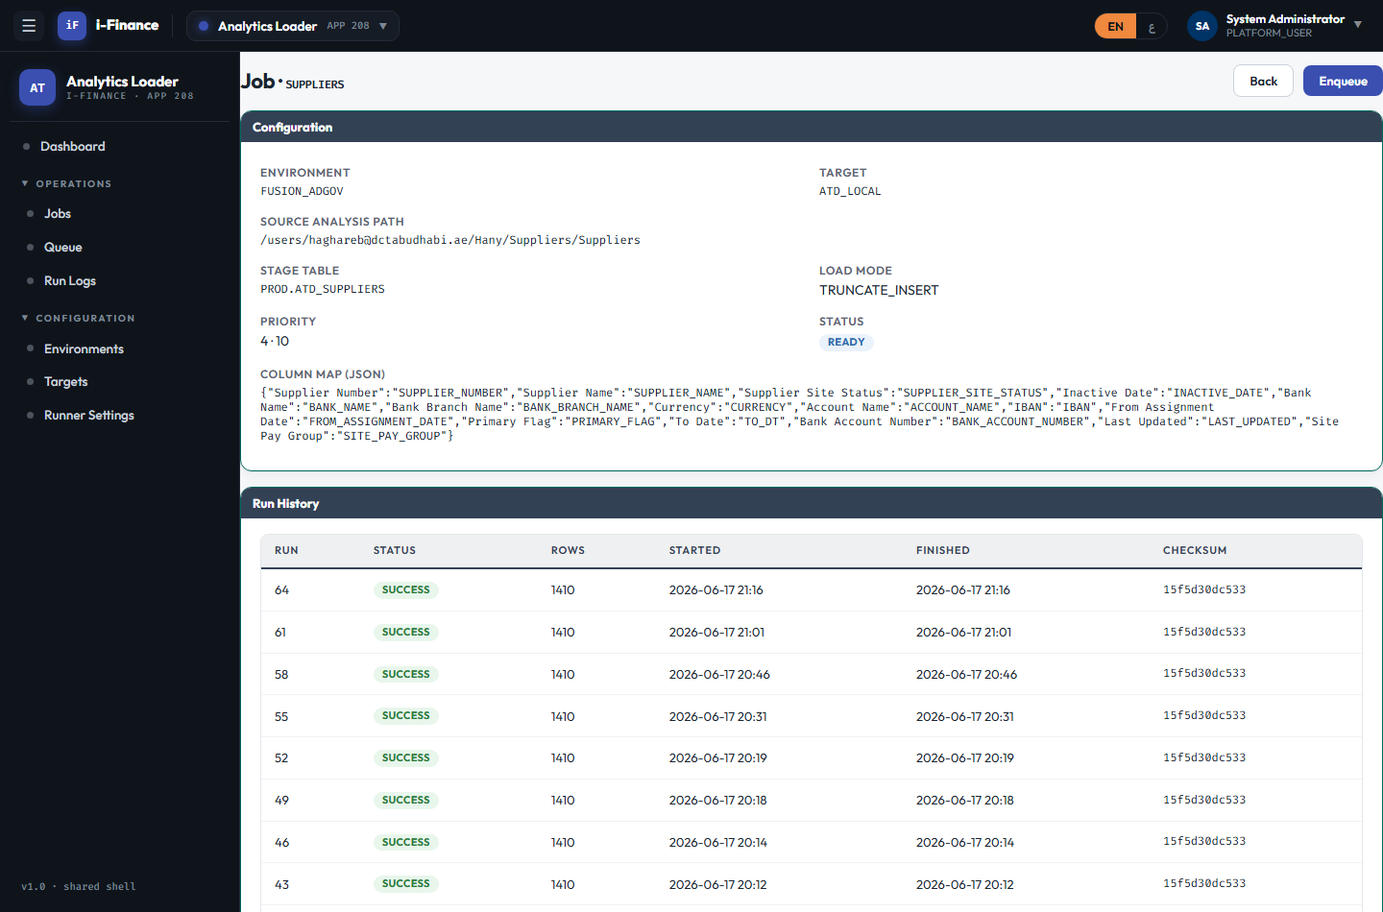
Evidence: ATD-DTL-01.png

Queue & Ops

ATD-QUE-01 — Queue every enabled job
PASS · Enqueue all · 2s
Expected: All enabled jobs marked READY
Result: Enqueue All marked 3 jobs READY
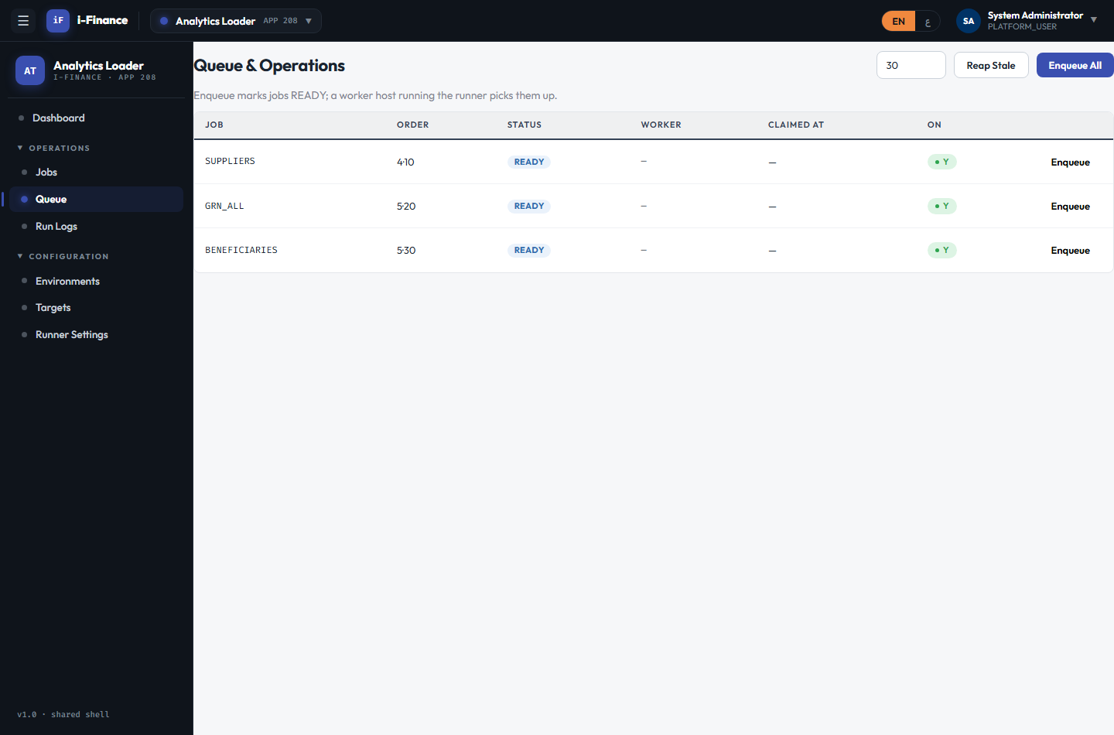
Evidence: ATD-QUE-01.png

ATD-QUE-02 — Reclaim stale leases
PASS · Reap stale · 2s
Expected: Stale CLAIMED jobs returned to READY (count reported)
Result: Reap Stale ran (reaped=0)
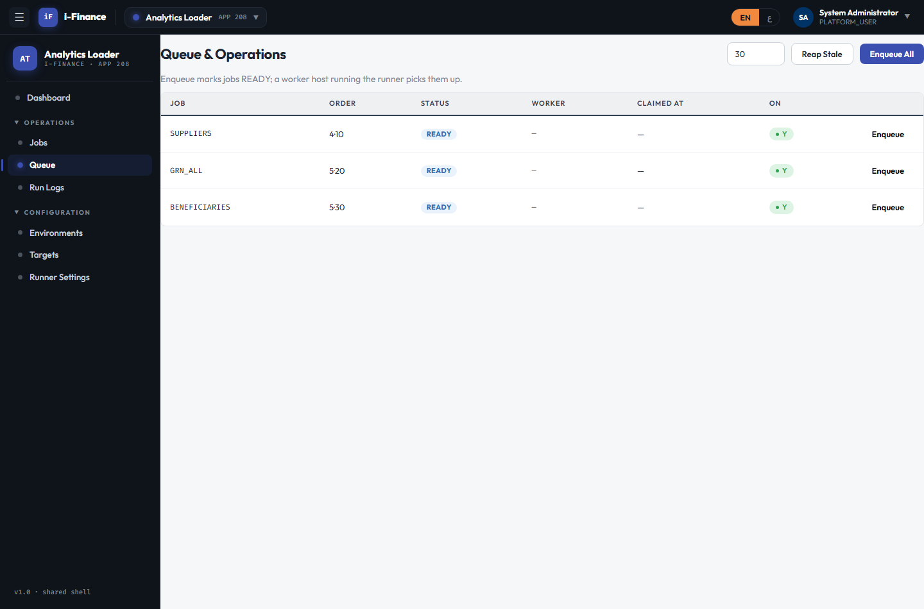
Evidence: ATD-QUE-02.png

Run Logs

ATD-RUN-01 — Run log loads
PASS · List · 2s
Expected: Filterable run log lists rows with status/rows/timestamps
Result: Run log shows 66 rows (API total=66)
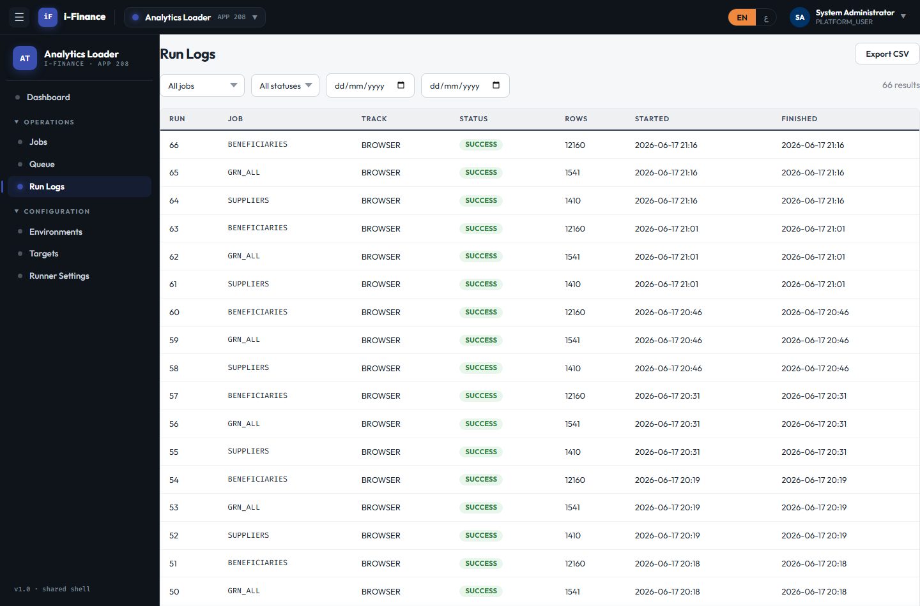
Evidence: ATD-RUN-01.png

ATD-RUN-02 — Run detail modal
PASS · Detail · 3s
Expected: Detail returns message + checksum; modal opens
Result: Run #66 detail returns message + checksum; modal opens
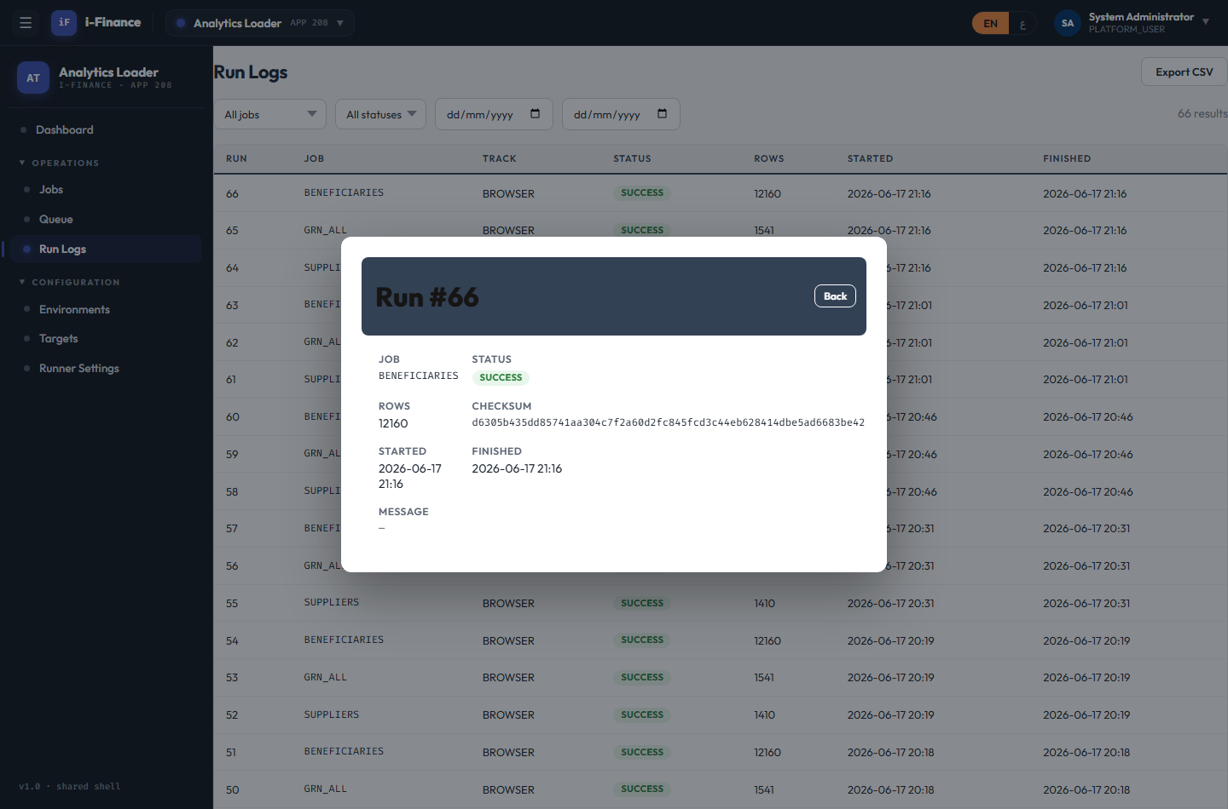
Evidence: ATD-RUN-02.png

ATD-RUN-03 — CSV export
PASS · Export · 2s
Expected: Server returns a CSV with a header row
Result: CSV export returns 4593 bytes with header row
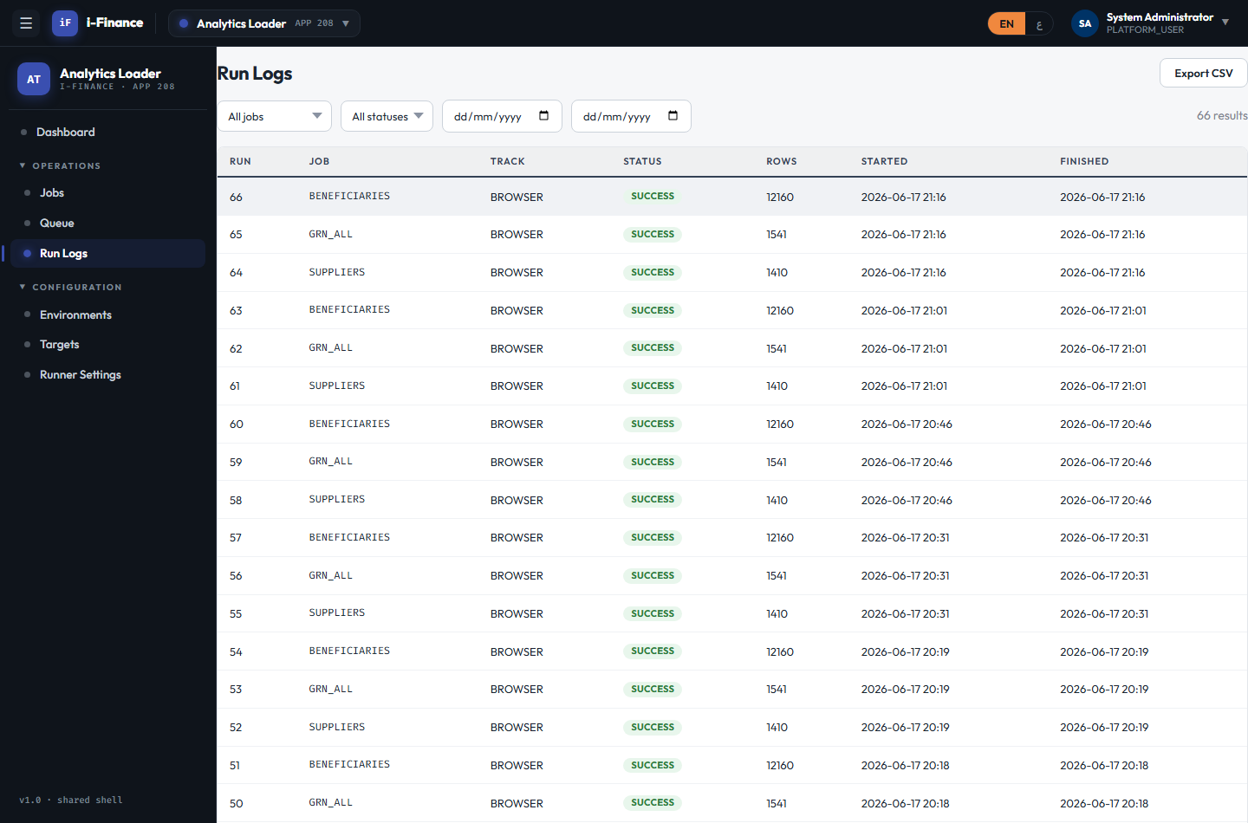
Evidence: ATD-RUN-03.png

ATD-RUN-04 — No token rejected
PASS · Unauthorized · 0s
Expected: Returns HTTP 401
Result: Unauthenticated /atd/runs returns HTTP 401

Evidence: ATD-RUN-04.png

Environments

ATD-ENV-01 — Environments load
PASS · List · 2s
Expected: Grid + API list the configured env(s)
Result: Environments grid + API list 1 env(s)
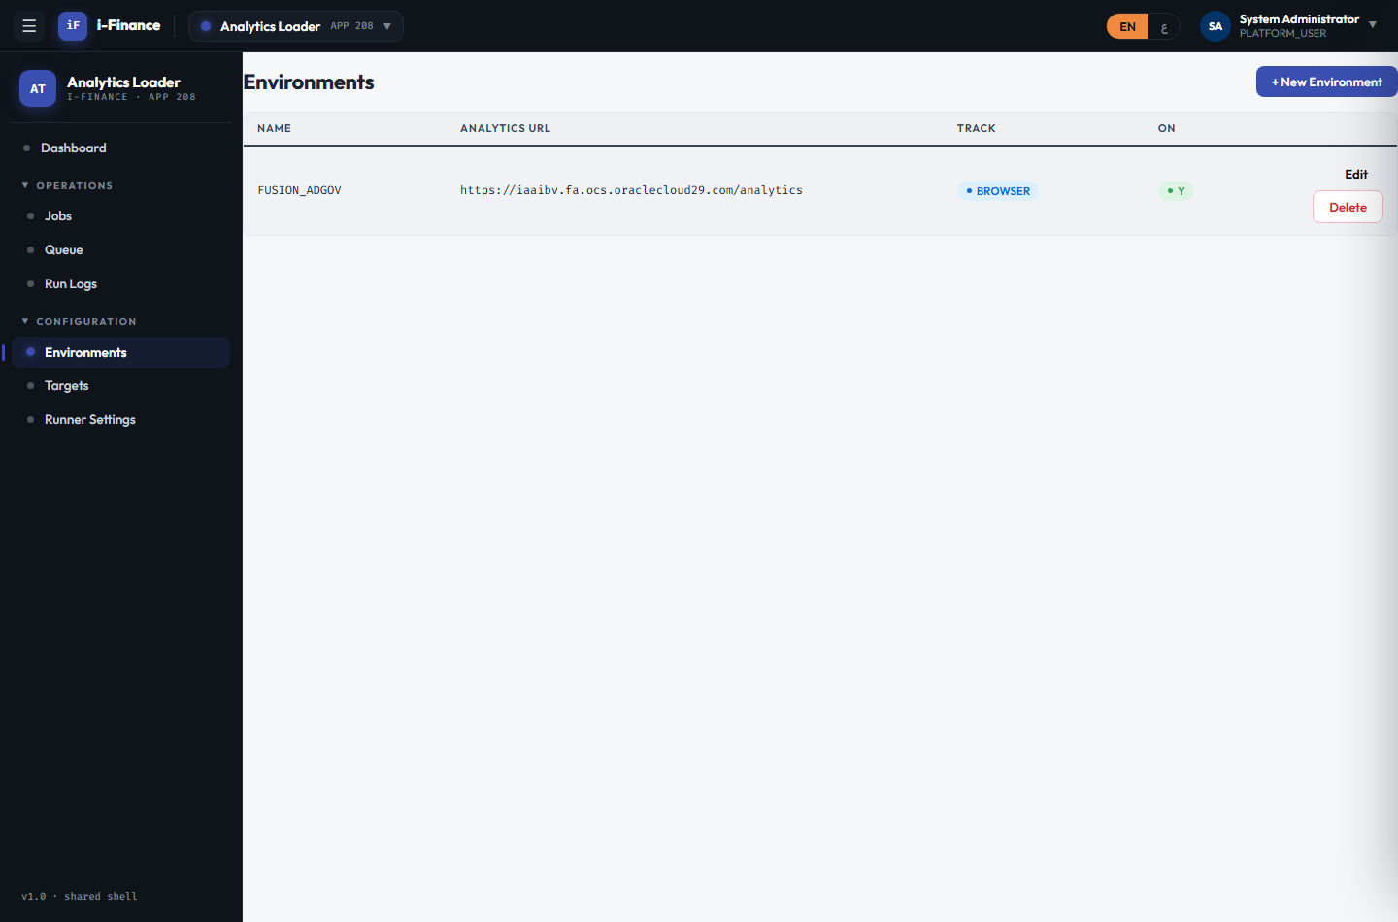
Evidence: ATD-ENV-01.png

ATD-ENV-02 — Create + delete
PASS · CRUD · 2s
Expected: Create + delete round-trip succeeds
Result: Environment create + delete round-trip OK
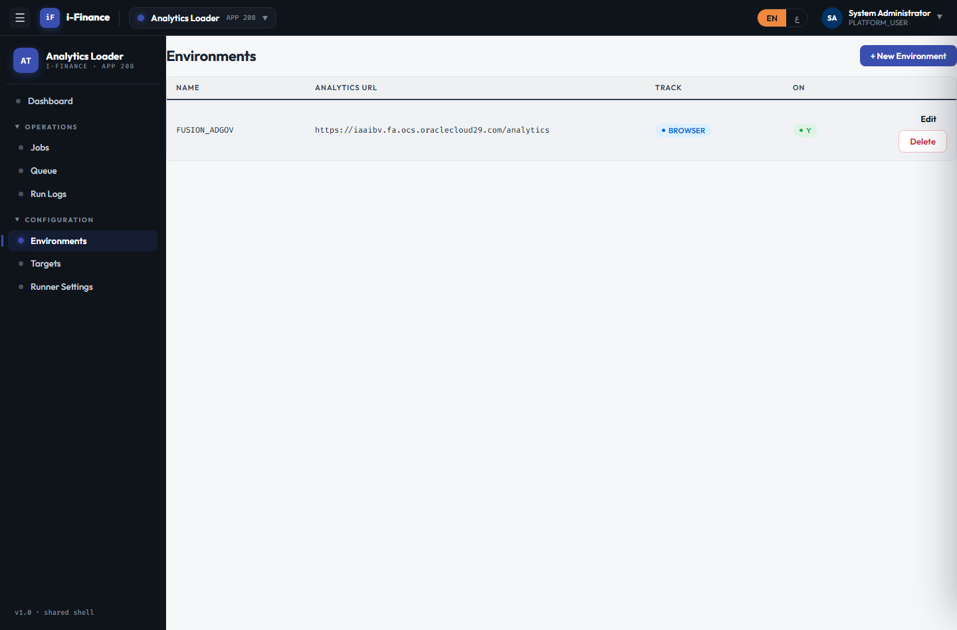
Evidence: ATD-ENV-02.png

ATD-ENV-03 — Delete env used by a job
PASS · In-use guard · 2s
Expected: Rejected with HTTP 400 (boundary)
Result: Deleting an env still used by a job rejected with HTTP 400 (boundary)

Evidence: ATD-ENV-03.png

Targets

ATD-TGT-01 — Create + delete
PASS · CRUD · 2s
Expected: Create + delete round-trip succeeds; grid renders
Result: Target create + delete round-trip OK; grid renders
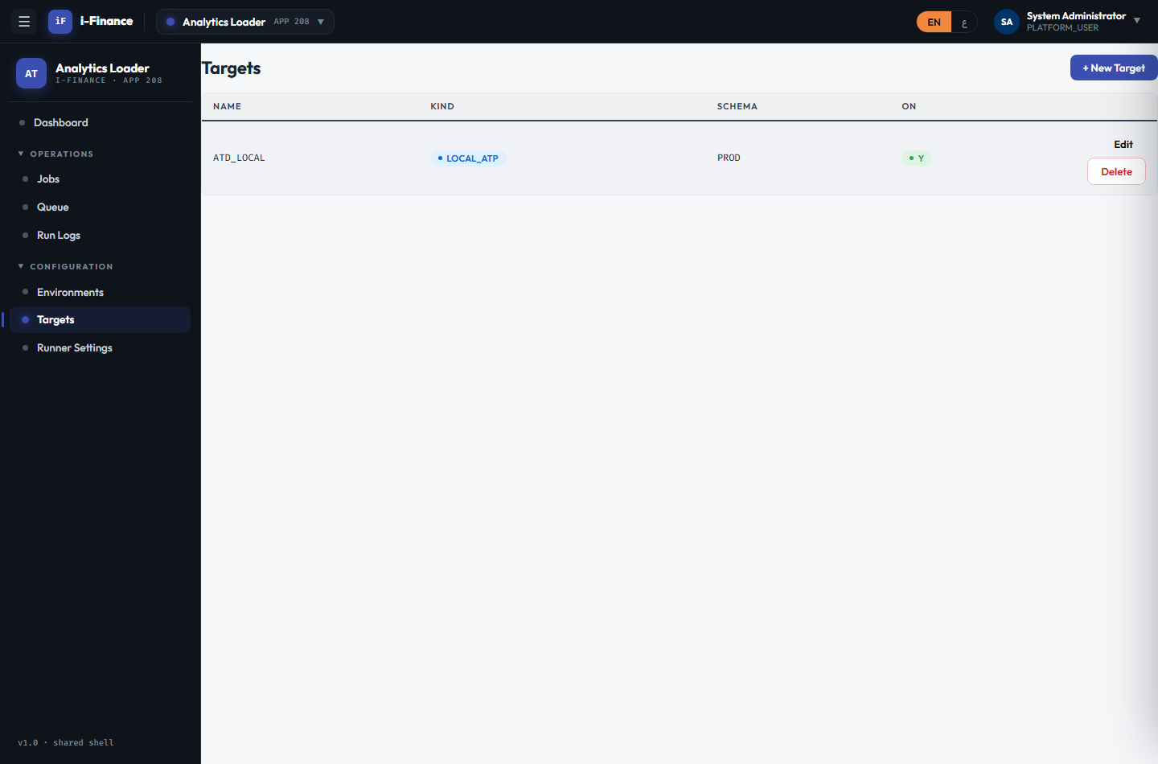
Evidence: ATD-TGT-01.png

Runner Settings

ATD-CFG-01 — Settings load
PASS · List · 2s
Expected: Operational settings render with per-type inputs
Result: Runner Settings shows 9 rows (API 9 keys)
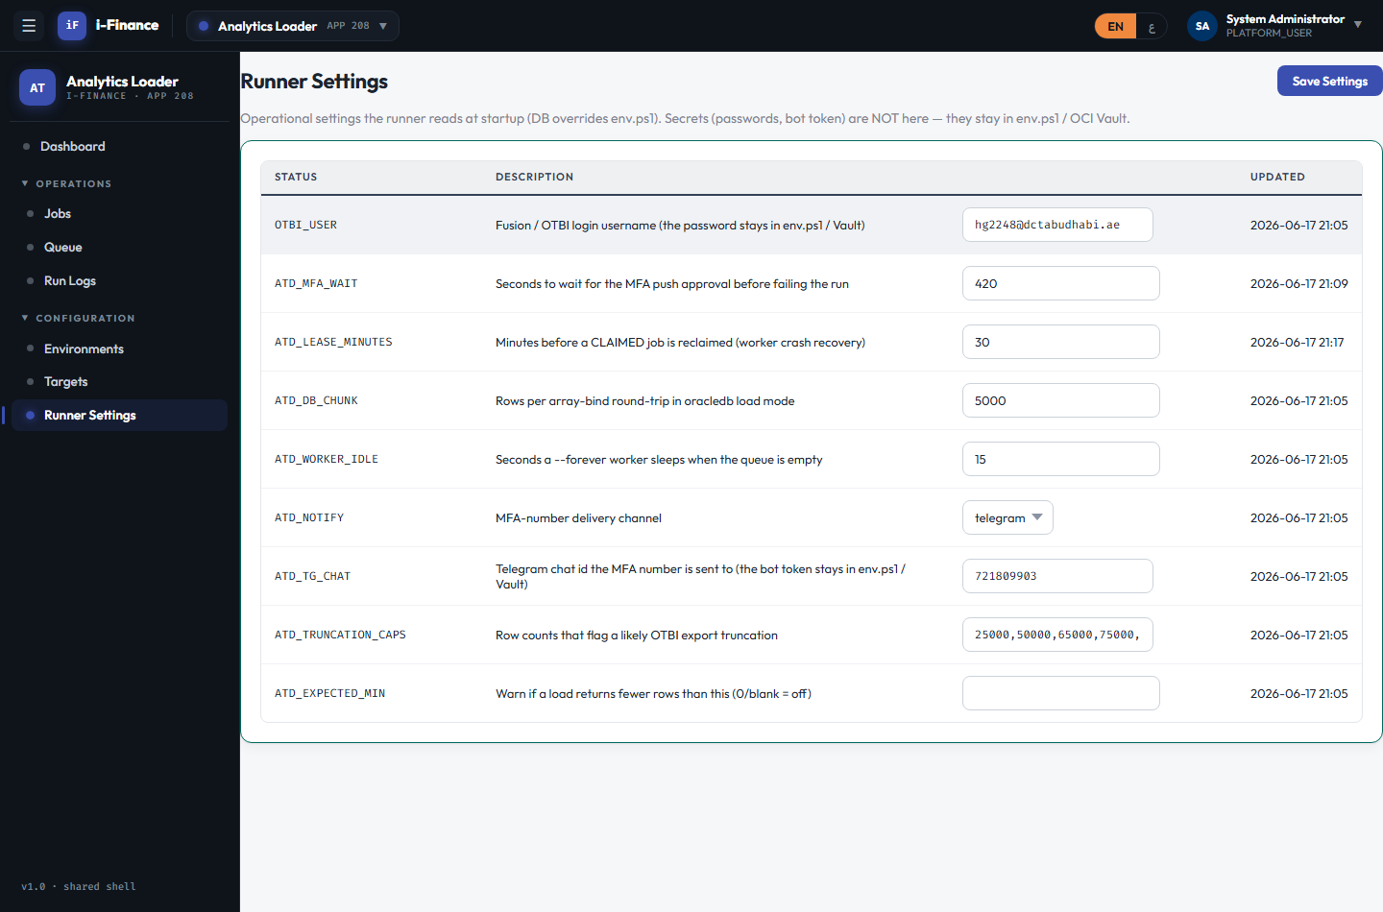
Evidence: ATD-CFG-01.png

ATD-CFG-02 — Setting persists
PASS · Edit · 2s
Expected: Value persists with updatedBy; runner reads it at startup
Result: Edited ATD_LEASE_MINUTES -> 25 (updatedBy recorded), reset to 30
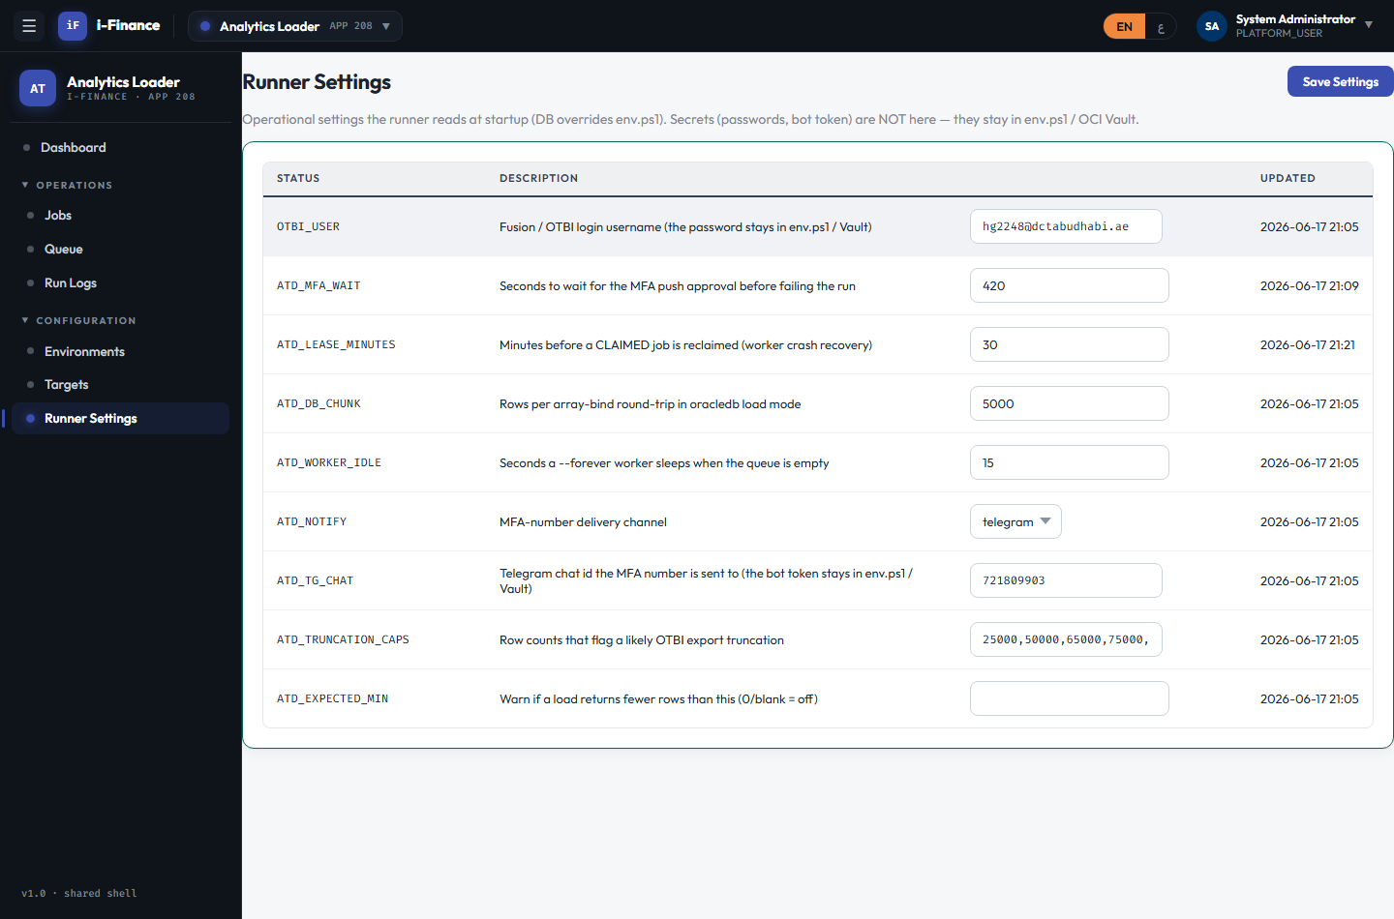
Evidence: ATD-CFG-02.png

ATD-CFG-03 — No secret leaked
PASS · Secrets masked · 2s
Expected: Secret values are never returned in clear (masked)
Result: No secret values returned in clear (0 secret keys, all masked)

Evidence: ATD-CFG-03.png

Cross-cutting

ATD-XCT-01 — EN ↔ AR RTL
PASS · Language · 4s
Expected: Shell flips RTL with Arabic labels; back to EN
Result: Language switch flips the shell to Arabic RTL and back
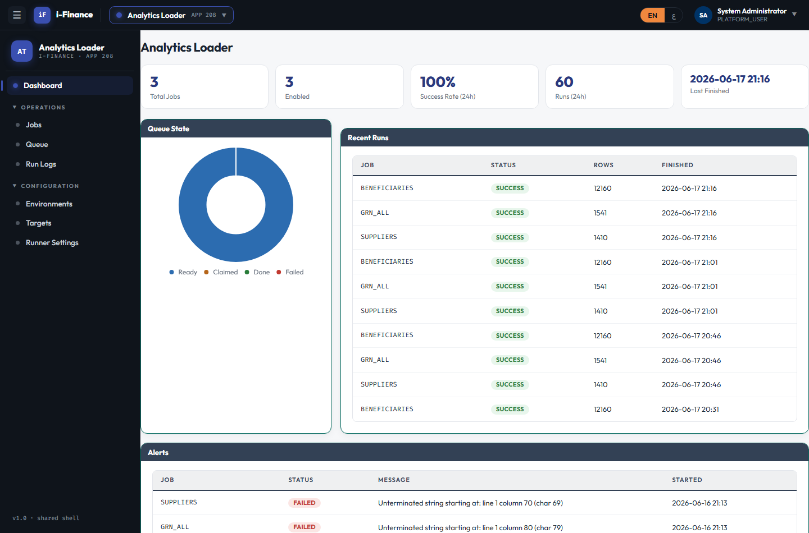
Evidence: ATD-XCT-01.png

